Day 08 Highlights

1. Reminders
   1. Project Two posted, due February 8 at 5pm
   2. zyBook Chapter 3 exercises due at midnight
2. Loops/iteration – last of (sequence/selection/iteration)

**While Loop For Loop**

**init for (init; test; update) {**

**while (test) { statement(s);**

**statement(s); }**

**update**

**}**

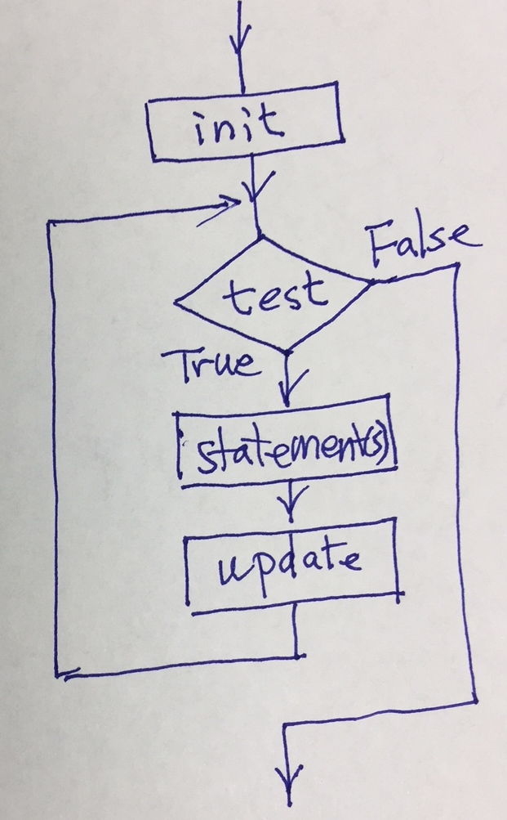

1. Examples (write both ways)
   1. Print the numbers zero to ten

**int a = 0; int b;**

**while (a < 11) { for (b=0; b<=10; b=b+1)**

**printf("%d\n", a); printf(“%d\n”, b);**

**a = a + 1;**

**}**

* 1. Print all the characters in a string

**int b;**

**for (b=0; b<strlen(str);** **b++)**

**printf(“%c”, str[b]);**

**printf(“\n”);**

**printf(“%s\n”, str);**

Practice – students should work at least four of the problems below

* Print the numbers 1 to 50,000 (on a single line separated by spaces)
* Print the numbers 1831 to 2016 (one per line)
* Print the numbers from 0 to 400 by 4, by 50, by 100
* Print the numbers from 100 to 0 by negative 5, by negative 10
* Read in a value (N) and print the sum of the first N numbers
* Read in 10 values and print their average
* Read in 10 values and print the largest and smallest values
* Print the string “The quick brown fox jumps over the lazy old dog” one character per line
* Print the string “The quick brown fox jumps over the lazy old dog” backwards

Homework – have them write

* Print the numbers 1 to 50,000 (on a single line separated by spaces)
* Print the numbers 1831 to 2016 (one per line)
* Print the numbers from 0 to 400 by 4, by 50, by 100
* Print the numbers from 100 to 0 by negative 5, by negative 10
* Read in a value (N) and print the sum of the first N numbers
* Read in 10 values and print their average
* Read in 10 values and print the largest and smallest values
* Print every other character in the string “The quick brown fox jumps over the lazy old dog”
* Print only the vowels in the string “The quick brown fox jumps over the lazy old dog”
* Count the number of spaces in the string “The quick brown fox jumps over the lazy old dog”